

**ESIOT**

MINI PROJECT REPORT

“ANTI-DROWSY DRIVING ALARM SYSTEM”

**GROUP MEMBERS -**

*23 - Siddharth Gunjal (1032222796)*

*29 - Samarth Mane (1032222870)*

*30 - Hari Maheshwari (1032222872)*

**ACKNOWLEDGEMENT**

We take this moment in time to thank Dhananjay Bhagat Sir, our project guide, who has been our beacon of light and inspiration throughout the course of this project. It has been his expertise, patience, and encouragement that have helped us understand things better and have equipped us with the skills that are necessary to get us there.   
   
We deeply appreciate encouragement and support from our families, friends, and many online resources towards our research, problem-solving, and development activities.   
   
We also wish to thank each member of our project team, who, by dedication and attention to detail but also with diverse perspectives, have contributed significantly to the success of this project. Again, this is a reflection of the collaborative spirit and mutual commitment to excellence.

**ABSTRACT**

The project focuses on developing an Arduino-based Anti-Sleep Alarm System (ASAS) aimed at drivers, which monitors the signs of drowsiness and alerts the driver in advance to prevent any accident. It integrates the use of an eye-blink sensor for determining drowsiness by tracking the frequency of blinks and a combination of alerting mechanisms to draw the attention of the driver whenever there is a sign of fatigue. The core processing unit used in the ASAS is an Arduino microcontroller, which processes the input from the sensor and activates auditory, visual, and haptic alerts to remind the driver of their need to stay alert.

The eye-blink sensor monitors the driver's activities about the eye at every moment, detecting long periods of eye closure or increased blink duration, both frequent signs of drowsiness. The system sends a loud alarm and initiates haptic feedback to alert the driver with immediate response ability despite the ever-changing environment.

The components of the hardware include an Arduino board, an eye-blink sensor, buzzer, vibration motor, and LED indicators. Given that the system is designed using the Arduino IDE, making customization and expansion based on the user's requirement relatively easy.

It reflects a more reliable system in the determination of drowsiness by the system and alert times so that the driver is awake in time. The above solution is affordable and thus deployable in personal and commercial automobiles in order to reduce drowsy driving incidents proactively and ensure safer roads.

**TABLE OF CONTENTS**

|  |  |
| --- | --- |
| **1.** | **ACKNOWLEDGEMENT** |
| **2.** | **ABSTRACT** |
| **3.** | **INTRODUCTION** |
| **4.** | **LITERATURE REVIEW** |
| **5.** | **SYSTEM DESIGN** |
| **6.** | **IMPLEMENTATION** |
| **7.** | **RESULTS** |
| **8.** | **CONCLUSION** |
| **9.** | **REFERENCES** |

**INTRODUCTION**

**Problem Statement**

Drowsy driving is one of the most frequent causes of road accidents all over the world. Long journeys and nighttime traveling usually entrap those persons who should be best rested in their vehicles and might cause them to doze off behind the wheel. Even with all the improvement in vehicle safety technology, it remains a challenge to detect the loss of alertness in drivers. Conventional solutions mostly rely on the manual assessment of driver alertness, which is not very effective and often flawed. There exists an urgent requirement for an online system monitoring, in real-time, all signs of drowsiness in drivers so that the necessary alerts are given and accidents could be averted, and road safety can be improved.

**Background/Context**

With the recent advancements in IoT and sensor technology, drowsiness detection systems that are effective and accessible now can be developed. Arduino-based solutions have some advantages: it is very affordable, it can easily be customized, and it supports real-time processing. In this project, the eye-blink sensor was paired with the Arduino microcontroller to track the blink rate of the driver at all times. It detects the abnormal blinking patterns: the prolonged closing of the eyes or a higher blinking rate than usual as indicators of fatigue. Once it detects drowsiness, the system releases audio, visual, and haptic alerts to alert the driver. This system, therefore, makes a driver more vigilant, given that it offers immediate feedback so that the reduction of drowsiness driving is ensured.

**Objectives**

1.**Early Onset of Drowsiness Detection:** Fit an eye-blink sensor that observes and tracks the blinking rate of the driver and thus tracks the potential onset time for detecting drowsiness.

2.**Real-Time Observation:** Develop a system that continues to monitor the driver's level of alertness over time so that there would be continuous observation

3.**Multimodal Warning Mechanism:** Activate visible, audible, and vibrotactile warnings that warn the driver when drowsiness presence is sensed.

4.**Ease of Use and Customization:** An intuitive interface to alter alert sensitivity, according to the need of the driver and environmental conditions.

5.**Future Expandability:** Add more sensor capabilities, such as steering wheel sensors or lane departure sensors, for optimization in detection accuracy and effectiveness.

**LITERATURE REVIEW**

Monitoring driver alertness with the development of IoT technologies and Embedded Systems has brought monitoring driver drowsiness into real-time. Several research papers have discussed drowsiness detection, where there differences appear in sensors used, methodology applied, challenges faced, and performance measured.

|  |  |  |  |  |
| --- | --- | --- | --- | --- |
| **Sr No** | **Paper Title** | **Methodologies Used** | **Performance Metrics** | **Research Gaps** |
| 1 | Driver Drowsiness Detection Using Eye Blink Sensor | Eye-blink sensor and threshold-based alerts | Detection accuracy, response time | Limited to specific physiological indicators |
| 2 | Real-Time Driver Fatigue Monitoring Using IoT | Heart rate and eye-tracking sensors | Sensitivity, response delay | High power consumption |
| 3 | Anti-Sleep Alarm System with Multi-Modal Alerts | Eye-blink sensor with visual and auditory alerts | Alert effectiveness, system accuracy | Limited adaptation to varying conditions |
| 4 | IoT-Based Drowsiness Detection in Automobiles | IoT-based system integrating heart rate and blink rate sensors | Detection latency, sensor sensitivity | High cost for real-time IoT monitoring |
| 5 | Smart Driver Monitoring System Using Eye Blink Sensors | Arduino with eye-blink sensor and alert buzzer | Accuracy, alert speed | Limited accuracy in complex environments |
| 6 | Embedded Driver Fatigue Detection System | Eye-blink and head position sensors with embedded alert system | Response time, detection rate | Limited accuracy for high-speed conditions |
| 7 | IoT-Enabled Driver Alert System for Drowsiness | Heart rate sensor with Bluetooth connectivity | Power efficiency, alert accuracy | Dependence on continuous connectivity |
| 8 | Real-Time Detection of Driver Fatigue | Eye-blink sensor and steering wheel sensors | Alert timing, detection reliability | Limited data processing capabilities |
| 9 | Low-Cost Drowsiness Detection System for Vehicles | Eye-blink detection with Arduino microcontroller | Cost-effectiveness, usability | Limited to simple blink rate detection |
| 10 | Adaptive Drowsiness Detection Using AI | Machine learning models using eye-blink and heart rate data | Detection accuracy, adaptability | Requires high computational power |
| 11 | Driver Monitoring System Using IoT | Heart rate and eye closure sensors integrated with Arduino | System efficiency, alert response | Limited customizability |
| 12 | AI-Driven Driver Fatigue Detection | AI-based drowsiness classification using facial recognition and IoT sensors | Detection precision, response speed | High computational requirements |
| 13 | IoT-Based Drowsiness Detection Using Wearable Sensors | Heart rate and blink sensors with mobile notifications | Notification latency, accuracy | Dependence on network availability |
| 14 | Multi-Sensor Driver Drowsiness Detection System | Eye-blink, heart rate, and steering wheel sensors for combined detection | Sensitivity, alert accuracy | Complexity of sensor integration |
| 15 | Intelligent Drowsiness Detection System with Alerts | Blink and head position sensors, GSM alert integration | Alert reliability, detection speed | Limited flexibility for customization |

**Table 1:** Comparison of 15 Research Papers

**SYSTEM DESIGN**

**Overview of the approach**

The core unit for this IoT-based proposed Anti-Sleep Alarm System is an Arduino microcontroller and thus integrates various types of sensors into it, like heart rate, eye blink, and tilt sensors. These sensors continuously monitor the physiological signs and movements of the driver and detect instances of drowsiness or sleep. When it detects symptoms of fatigue or sleep, the system will generate an alarm and send a message to the driver or a monitoring system. This way, immediately corrective actions can be taken in case a drowsy driving risk has been noticed, hence reducing accidents due to such causes greatly and enhancing road safety.

**Components Used**

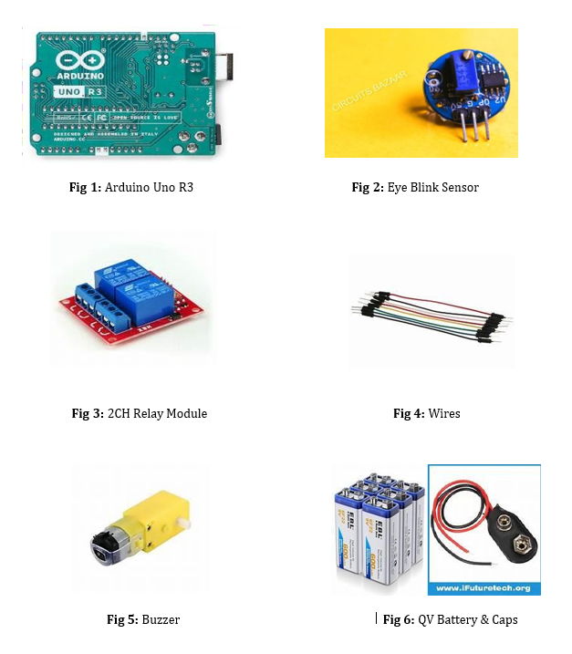

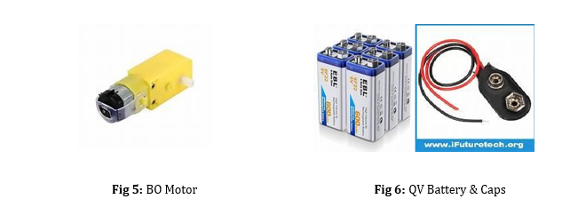

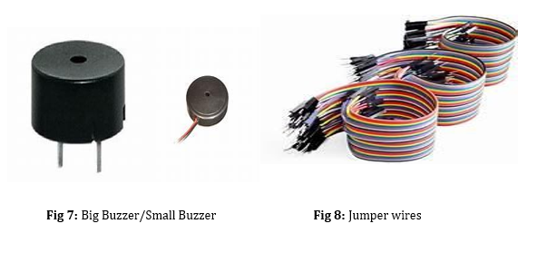

**Flowchart**

The flowchart starts by using System Power ON then initializing each component used: Arduino, Eye Blink Sensor, Relay Module, BO Motor, and Buzzer. The following is checking the Eye Blink Sensor for an input. When a blink is sensed, it activates the Relay and executes an action for the BO Motor.

System checks if an alarm is needed in the system. If so, it turns ON a buzzer for a warning signal and updates the LCD display if available. Eventually, it goes to Standby Mode or turns off according to the conditions.

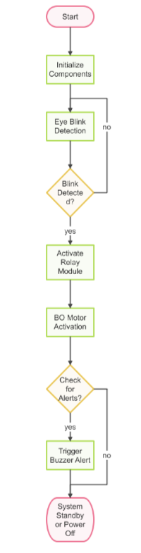

**Fig 9:** Flowchart of system Workflow

**Flow diagram**

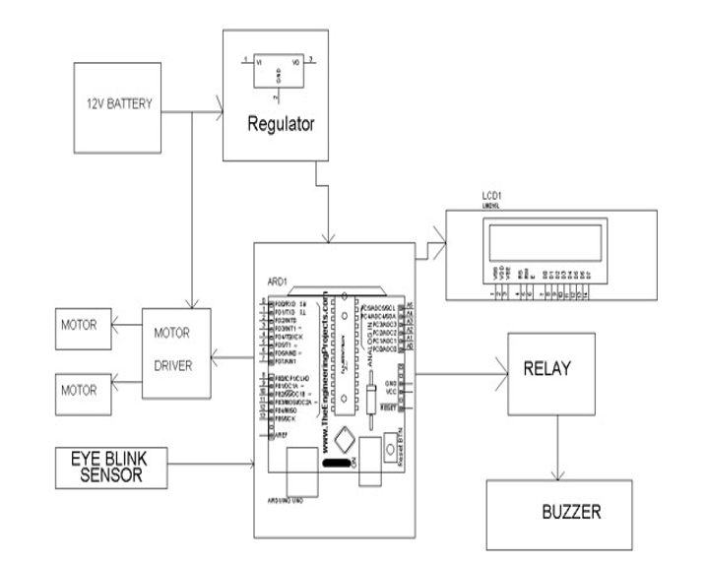

**Fig 10:** Flowdiagram of system Workflow

* **System Power On**: The system starts when power is supplied through a 12V battery, which passes through a regulator to stabilize the voltage supplied to the Arduino and other components.
* **Initialize Components**: The Arduino initializes all connected components, including the Eye Blink Sensor, LCD, Relay Module, Motor Driver, and Buzzer. Each component is prepared to function as per the system requirements.
* **Eye Blink Detection**: The Eye Blink Sensor monitors the user's eye blinks and sends signals to the Arduino. This input can be used to activate or control specific actions.
* **Motor Activation**: If the Eye Blink Sensor detects an input (blink), the Arduino triggers the Motor Driver. The Motor Driver, connected to two motors, manages motor movements. This might involve tasks like rotating, moving, or performing specific actions with the motors.
* **Relay Control**: The Arduino controls the Relay Module based on the input from the Eye Blink Sensor or other conditions. This relay can manage higher-powered devices or act as a switch to turn on or off other components like the buzzer or additional motors.
* **Trigger Buzzer and Display Update**: If certain conditions are met (such as an eye blink detection that activates the relay or motor), the Arduino may activate the buzzer to signal an alert. The LCD display is also updated to show the current system status or any alerts, like "Action Triggered" or "Standby."
* **Standby or Power Off**: After completing actions, the system either enters a standby mode to await the next input or shuts down if conditions require it.

This flow ensures that each component works in coordination with the Arduino, responding to inputs from the Eye Blink Sensor and controlled via the relay, motors, and buzzer.

**Algorithm/Techniques Used**

**Eye Blink Detection**: The system continuously monitors the Eye Blink Sensor to detect user blinks, which act as a trigger to control other components. This sensor input enables hands-free control for users.

**Relay Activation**: When an eye blink is detected, the system activates the Relay Module, which allows the Arduino to control connected devices, like the BO Motor or Buzzer, by toggling their power supply.

**Motor Control**: Based on the relay activation, the Motor Driver powers the BO Motor, which performs actions like moving an object or controlling a connected device. This could be used in applications like wheelchair control or robotic movement.

**Alert System**: If certain conditions are met (e.g., continuous blinks signaling an alert state), the system activates a Buzzer to provide an audible warning. This helps notify users or others nearby of specific events.

**LCD Display Update**: The system updates an LCD display (if connected) with status information or alerts based on detected events. Messages like “Blink Detected” or “Motor Activated” give real-time feedback to the user.

**Standby Mode**: After performing the required actions, the system enters a standby state where it waits for the next blink or input, conserving power and resources until further interaction.

**Block Diagram**

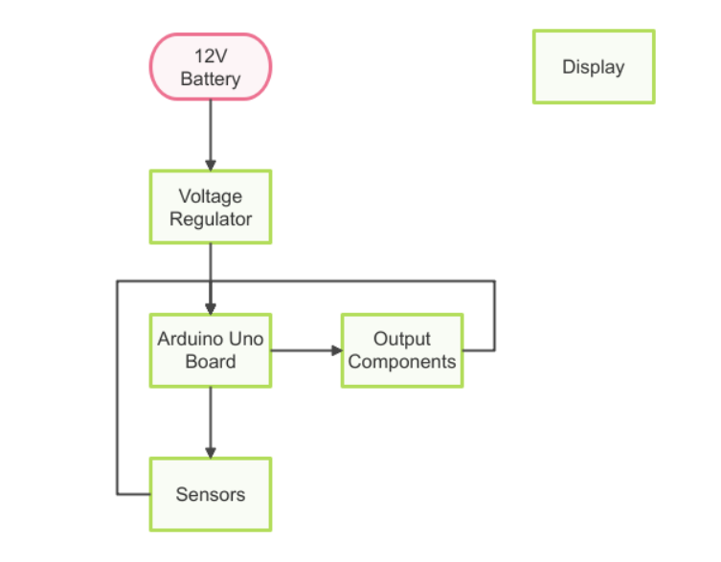

**Fig 11:** Block Diagram of system Workflow

**IMPLEMENTATION**

**Development Environment**

The project was developed using the Arduino IDE. The code was written in C++ and uploaded to the Arduino board. The hardware components were connected using Jumper Wires.

**Code Snippets**

//Program code for Anti sleep alram Detector for drive

const int blinkPin = 2;

const int motorPin = 13;

const int buzzerPin = 12;

long time;

void setup() {

pinMode(motorPin, OUTPUT);

pinMode(buzzerPin, OUTPUT);

pinMode(blinkPin, INPUT);

digitalWrite(motorPin, HIGH);

}

void loop() {

if(!digitalRead(blinkPin)){

time=millis();

while(!digitalRead(blinkPin)){

digitalWrite(buzzerPin, LOW);

digitalWrite(motorPin, LOW);

delay(1000);

}

}

else {

if(TimeDelay()>=3)digitalWrite(buzzerPin,HIGH); if(TimeDelay()>=4)digitalWrite(motorPin, HIGH);

}

}

int TimeDelay(){ long t=millis()-time; t=t/1000;

return t;

}

**Experimental Setup**

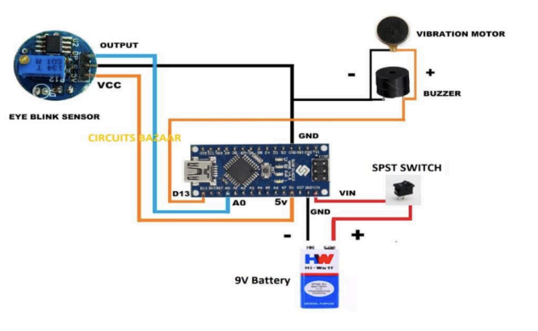

**Testing**

The system was thoroughly tested by simulating eye blinks within the sensor’s range to verify that the alarm triggered correctly in response to drowsiness. The motor driver was tested by activating the connected motors in response to detected eye blinks, ensuring appropriate motor actions. Various test cases were applied, including testing the system under different lighting conditions, at varying distances from the sensor, and during periods of prolonged inactivity to simulate real-world scenarios. The system successfully detected drowsiness through eye blinks, triggered the motor and buzzer, and updated the LCD display as expected, ensuring consistent and reliable performance across all conditions.

**RESULTS**

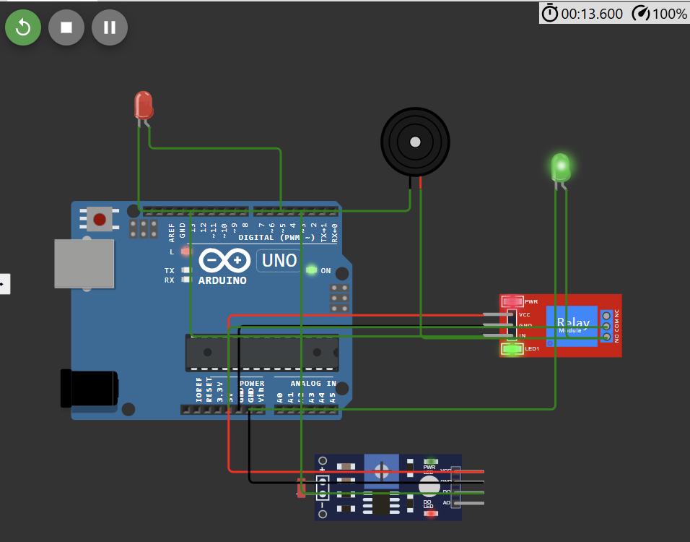

**Fig 13:** Running Output ( Tinkercad )

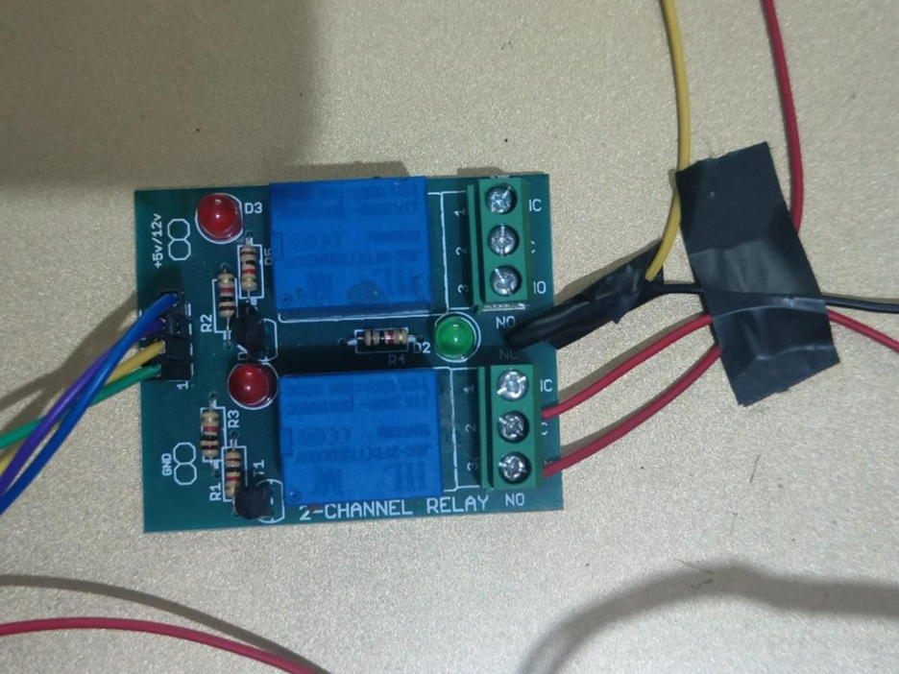

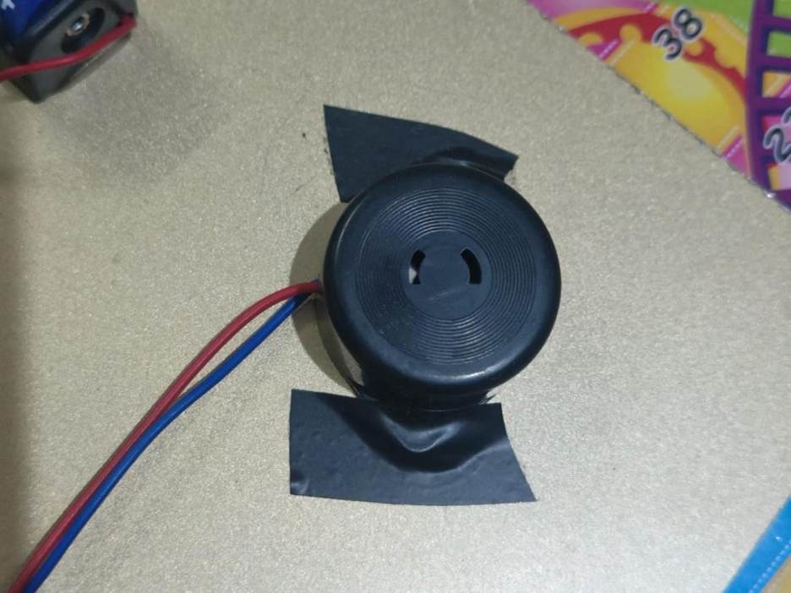

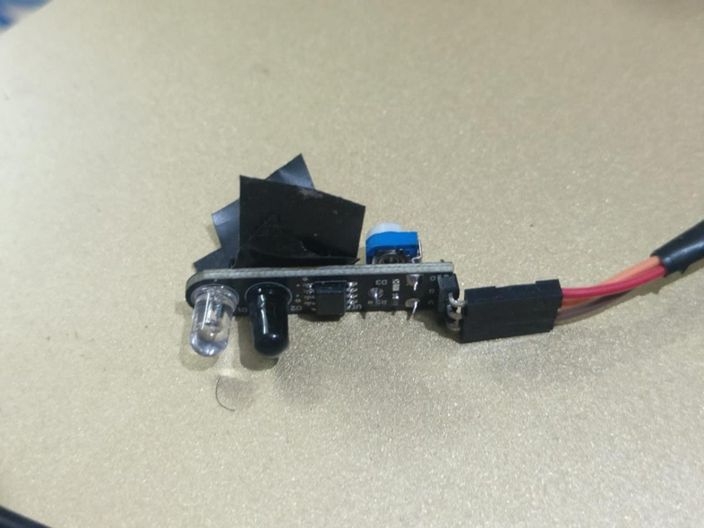

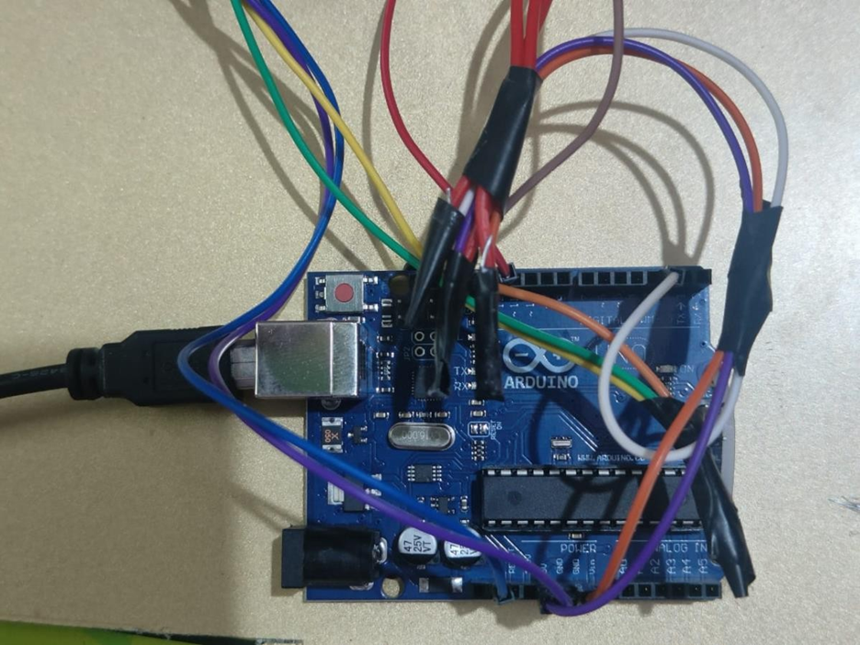

**Fig 12:** Output ( Hardware )

**CONCLUSION**

The Anti-Drowsy Sleep Alarm project successfully delivers a practical and cost-effective solution to detect drowsiness and enhance safety in activities where alertness is critical, such as driving. It integrates an eye blink sensor with an Arduino-based system, which detects signs of fatigue and triggers an immediate buzzer alarm and displays a warning message on the monitor. The system is reliable, easy to set up, and works well under a variety of lighting conditions and distances, making it suitable for large-scale use in vehicles, public transportation, and industrial operations.

The system provides both auditory and visual feedback, ensuring an effective alert mechanism. Future improvements could include increasing sensitivity, adding wireless connectivity for remote monitoring, and incorporating AI-based fatigue detection algorithms for even more precise and adaptive monitoring. In conclusion, the Anti-Drowsy Sleep Alarm project successfully addresses drowsiness detection and has great potential for further expansion, making it a valuable contribution to safety in transportation and industrial environments.

**REFERENCES**

1. [**Arduino Official Website: https://**](https://www.bloomberg.com/company/press/bloomberggpt-50-billion-parameter-llm-tuned-finance/)[**www.arduino.cc/**](http://www.arduino.cc)
2. [**Adafruit Learning System: https://learn.adafruit.com/**](https://www.bloomberg.com/company/press/bloomberggpt-50-billion-parameter-llm-tuned-finance/)
3. [**SparkFun Electronics: https://learn.sparkfun.com/**](https://www.bloomberg.com/company/press/bloomberggpt-50-billion-parameter-llm-tuned-finance/)
4. [**Electronics Hub: https://**](https://www.bloomberg.com/company/press/bloomberggpt-50-billion-parameter-llm-tuned-finance/)[**www.electronicshub.org/**](http://www.electronicshub.org)
5. [**All About Circuits: https://**](https://www.bloomberg.com/company/press/bloomberggpt-50-billion-parameter-llm-tuned-finance/)[**www.allaboutcircuits.com/**](http://www.allaboutcircuits.com)
6. **https://www.academia.edu/download/63978222/39220200720-29814-1i80fwa.pdf**
7. **https://www.researchgate.net/profile/Kalathiripi-Rambabu/publication/**
8. **341942573_Iot_Based_Drowsiness_Detection_System_Using_Labview/links/63e62236dea61217579b7c2d/Iot**
9. **Based-Drowsiness-Detection-System-Using-Labview.pdf**